**Memorandum**

Date: 8/24/2010  
To: Mr. Professor Name  
From: Student One and Student Two  
Subject: Sample Informal (Memo) Report

**Summary**

The objective of this report is to demonstrate the correct *informal report* format, as well as give some general information about writing technical papers and reports. Most importantly, the entire report is written in third person, meaning there are no references to “I,” “we,” “us,” “you,” etc. For the purposes of demonstration, a laboratory exercise will be described in which the experimenter measured the values of various resistors. These resistors have a specified tolerance of +/-10%, and the measured data supports the manufacturer’s claim.

# Experimental Results

Figure 1 shows how to determine the specified value for a given resistor. The most resistors use a 4-band color code, which is at the top of the chart.

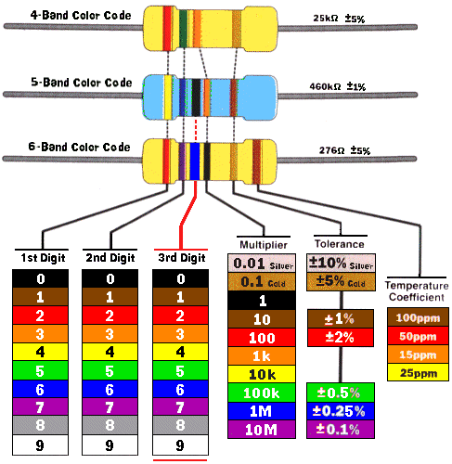

Figure . Resistor color code chart [1].

Note the reference in the caption for Figure 1. This is the standard IEEE format for references [2], which are listed in the *References* section (below) in the order that they are cited.

Also note that the picture was originally larger than is currently appears and was automatically pushed to the next page. In order to avoid unnecessary white space, the picture was made smaller so it would fit on the first page but not so small that it was no longer readable.

Microsoft Word makes it easier to keep track of numbering (for figures, tables, equations, etc.) as well. The caption for Figure 1 was created by selecting (clicking) the picture, then choosing “Insert Caption” under the “References” tab (in Word 2007). Then a reference to the figure (like the one in the previous sentence) can be made by choosing “Cross-reference” under the “References” tab, selecting “Figure” for the “Reference type,” selecting “Only label and number” for “Insert reference to,” selecting the appropriate figure under “For which caption,” and clicking “Insert.” This will insert the text “Figure #” at the cursor, where # is linked to the figure chosen and will automatically update as figures are added or moved around. The same process works for tables and equations, provided that the appropriate “Reference type” is chosen.

A GenRad 1657 RLC Digibridge was used to measure various resistors’ values, which are given in Table 1.

Table 1. Measured versus specified resistor values.

|  |  |
| --- | --- |
| Specified Value (Ω) | Measured  Value (Ω) |
| 10 | 10.80 |
| 22 | 22.13 |
| 47 | 48.35 |
| 100 | 92.39 |
| 220 | 236.15 |
| 470 | 432.99 |
| 1 k | 1013.18 |
| 2.2 k | 2010.52 |
| 4.7 k | 5029.65 |
| 10 k | 9272.85 |
| 22 k | 23982.49 |
| 47 k | 48428.42 |
| 100 k | 99949.95 |
| 220 k | 229101.08 |
| 470 k | 434293.87 |

Recall that resistance can also be calculated using one of the following formulas:

1. $R=\frac{V}{I}$ (Ohm’s Law)

$R=\frac{V^{2}}{P}$

$R=\frac{P}{I^{2}}$

These formulas were written using Microsoft Equation Editor. This editor makes writing equations much easier and formats them nicely. If the equation does not have text next to it (e.g. the numbering with the formulas above), then it should be centered, which the editor will do automatically for you.

$$e=mc^{2}$$

Typically, you do not want to end a section, or the report, with anything other than text (i.e. a figure, equation, etc.).

# Conclusions

The resistors that were measured have a specified tolerance of +/-10%. Table 1 shows that, indeed, the measured values are within +/-10% of the specified value of each resistor. Thus, the data support the manufacturer’s claim. A number of pointers about report writing were also given. Additional information can be found in [3].

# References

[1] Michaels-Electronic-Lessons.com (2010). *Resistor Color Code*. [Online]. Available: <http://www.michaels-electronics-lessons.com/resistor-color-code.html>.

[2] D. Graffox (2009, Sept). *IEEE Citation Reference*. [Online]. Available: <http://www.ieee.org/documents/ieeecitationref.pdf>.

[3] *Laboratory Report Formats.* Dept. Elect. and Comput. Eng., Baylor University, Waco, TX, 2010.